**Zavionix Ethos widgets installation manual**

Thank you for using the Zavionix widgets on your radio, these widgets have been designed by a modeler, for modelers and as such, are given to you totally free for personal use.

**Distribution or forwarding of the widget files is prohibited**

If you know anybody interested in obtaining the widgets, please ask them to email: [zavionixrc@gmail.com](mailto:zavionixrc@gmail.com) with their request, and it will be handled in a timely manner.

Widget installation:

1. The first stage is always connecting your RDT and discovering sensors in Telemetry – Discover Sensors.
2. RDT also uses some DIY sensors called 0A10 and 0A20, depending on ECU type.  
   To discover these go to Telemetry -> DIY Sensor -> Auto Detect. If you have more than one sensor (i.e 0A10, 0A20) then you have to discover one, go back to telemetry menu, then repeat the process for the other.
3. **Only For ECU types Jetcentral, Jetcat and Projet** - please edit the settings under DIY 0A10 sensor and choose the following:  
   Range – change top value change from 10000 to **Max** (1000000000)  
   Protocol Precision/Unit – change from 0 to 0.00

On to the Widget iself:

1. Widget files are compressed in RAR format. If you do not have a tool to extract the files please download Winrar for free from: [www.winrar.com](http://www.winrar.com)
2. Extract the RAR files, inside it you will find a folder with the widget name (for example: RDT).
3. Before you copy the widget to your radio SD card please bear in mind that Ethos needs version 1.1.0 and above to run widgets. If you have not yet installed this version you may do so by obtaining the files and installing them on your radio from the following link:  
   <https://github.com/FrSkyRC/ETHOS-Feedback-Community/releases>
4. Copy the RDT widget folder to the SD card “scripts” folder. If this folder does not exist on your SD card, please create a folder called **scripts** on the root of the SD.
5. For example, for RDT widget, the SD should have a folder called **scripts**, inside it a folder called **RDT** and inside it the main.lua and all other files.
6. If you accidentally created any sub folders in the process, the widget will not work. So please make sure #7 and #8 are done correctly.
7. Once all files have been copied, start your Ethos radio.
8. Go to screens menu (DISP button from main screen).
9. Add a new screen (screen 2 for example).
10. Choose screen layout. RDT needs FULL SCREEN (bottom most option):  
    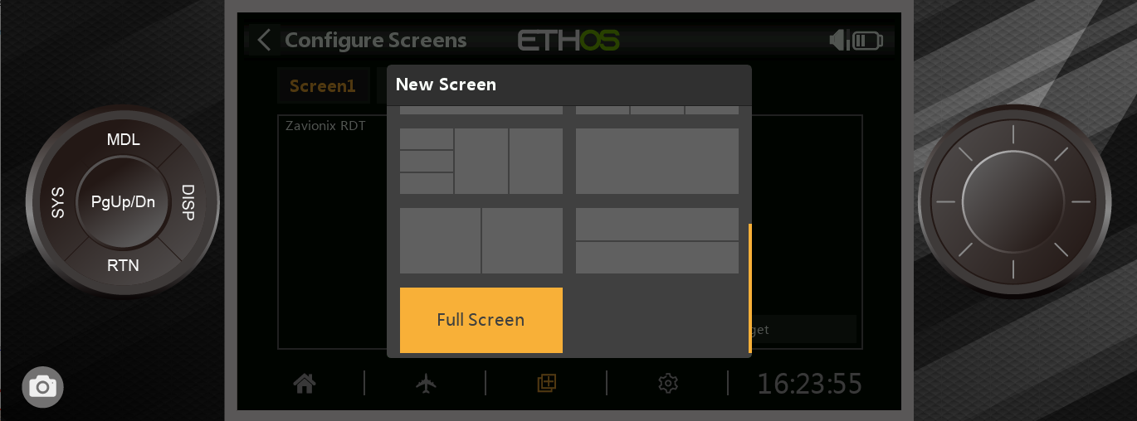
11. Select “Configure Widget” and choose the appropriate widget from the list – Zavionix RDT.
12. Exit back to main screen.
13. Scroll to widget page using the **Page** button.
14. Once you are on the widget screen, click **Enter** (center of rotary) and **Configure Widget**.
15. In the widget setting go through every line and choose the appropriate option (sensor sources, alert parameters etc).  
    the sensor allocation list per ECU type can be found in the attached Excel sheet:   
    **RDT sensor configuration for Ethos.xls**
16. Click RTN a few times to Exit back to main page.
17. Enjoy your new widget!
18. Post on the Frsky facebook groups and tag @Zavionix 😊

Fuel Factor Calibration:

Note: Not relevant for ECU type Jetcat, Projet, Jetcentral (as these report their own fuel amount without calibration).

1. Note your current fuel factor, for this example we will use 100.
2. Define your fuel tank size in the widget, for the example lets assume 3000ml.
3. Fly / run the model with a preknown amount of fuel, for this example lets assume 1000ml was burned.
4. note the remaining fuel amount indicated by the widget, lets assume widget shows 1500ml left.
5. New factor calibration is:   
   old factor * (Actual Burned fuel amount (1000) / (tank size – remaining fuel indicated by the widget)).  
   in our example: 100 * (1000/(3000-1500)) = **66.6**
6. Define the new fuel factor in the widget settings.
7. Define a proper fuel level alert and enjoy this amazing feature 😊

If you like our work and would like to show your appreciation, a donation goes a long way to keep the free work going, and you may do so by using paypal: [i3dm@hotmail.com](mailto:i3dm@hotmail.com)

Thank you.